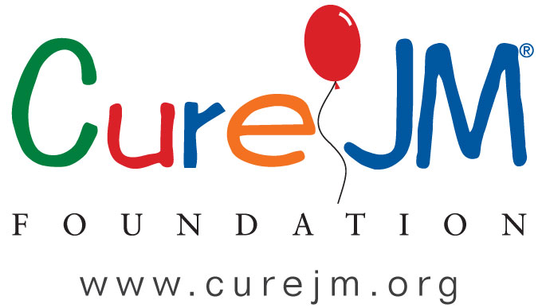
CURE JM FELLOWSHIP AWARD in JUVENILE MYOSITIS
The mission of Cure JM is to find better treatments and a cure for Juvenile Myositis, and improve the lives of families affected by JM.
The purpose of the fellowship award is:
To support the training of physicians or researchers in pediatric rheumatology to gain clinical and research expertise in Juvenile Myositis.
Award Amount:
$60,000-$70,000 year for up to 2 years
Eligibility & Requirements:
- MD, DO, or a PhD and completed a pediatric residency program in Juvenile Myositis or completed significant research-based residency/position with a focus in Juvenile Myositis.
- First, second or third year fellows in pediatric rheumatology at a center that trains physicians in the specialty of Juvenile Myositis.
  - OR a first, second or third year fellow in a recognized research facility, university, or hospital that has an active Juvenile Myositis based research program.
  - OR a pediatric rheumatology fellowship training program that contain a separate clinical year. An award for up to two years towards support of the research training component of a maximum three-year research/clinical fellowship.
  - OR a one-year extension of an existing fellowship or research program, applicants must have completed three years of a fellowship or research program.
- The fellowship may be awarded to doctors in an American Board of Pediatrics approved pediatric rheumatology training program in the United States, that has a clinical and research program in Juvenile Myositis.
- The fellowship may also be awarded in basic, clinical or translational research to PhD qualified applicants completing a fellowship program at an internationally recognized institute, university or hospital located in the United States.
- Must be able to devote at least 75% of their time to research.
Award Terms:
- A Fellowship recipient will receive $60,000-$70,000 a year to support salary and fringe benefits or laboratory supplies and for attendance at the Cure JM annual conference.
- The award is paid in two equal installments to the institution in July and January as outlined below.
- Other trainee expenses are to be covered by the recipient’s institutional program.
Application Deadline: January 30th, 2020
Notification of Award: March 30th, 2020
Award term begins: July 1st, 2020
Year 1 Year 2
Payment 1 July 2020 July 2021
Payment 2 January 2021 January 2022
- Proof of research progress must be submitted after the completion of year one of the award.
- At the end of the award period, the institution must provide Cure JM with a final budget reconciliation. All unused funds must be returned to Cure JM Foundation.
The fellowship recipient is required to attend the annual Cure JM conference and GCOM 2020. (Cure JM may provide additional funding to attend Global Conference on Myositis-GCOM--2020)
Fellowship Award Review
Application and research proposals are reviewed by selected members of CARRA or other experts in the field utilizing the NIH Grant Application Scoring System. The proposal scores along with feedback from the reviewers will be shared with the Cure JM Research Committee for evaluation. The Research Committee will make recommendations for funding to the Cure JM Board for a final funding decision. Applicants will be notified by the Cure JM Director for Research when a decision is made.
Reports and Payments
A progress report is required to be submitted by the award recipient and shall be due no later than 30 days after the close of the first year. A Final Report including a financial report is required within 60 days after the end of the fellowship award period. A layperson summary (300 words or less) of major accomplishments and relevance to JM patients shall accompany the progress report and the final report. Award payments will be made as outlined above.
Proprietary Information
All Cure JM funded research must contain a lay person abstract for Cure JM’s use in press releases. Cure JM Foundation must be acknowledged in all dissemination materials (e.g. publications, scientific exhibit, scientific presentations etc.) related to research conducted by or in association with the fellowship award recipient and one copy of any published reports must be sent to Cure JM within 30 days of final production.
Cure JM Foundation Fellowship Award in Juvenile Myositis Application
A complete application will include the following sections:
- Research Summary – including a plan abstract (no more than 300 words) and a Lay summary (no more than 300 words at the eigth grade reading level written so a person can understand the significance, impact and innovation of the proposed research) for use in Cure JM press releases. See attached form.
- Biographical Sketch – for key personnel in NIH format.
- Letter of Support – from the Fellowship Program Director certifying a fellow’s status in the Fellowship/Research program and a brief description of the program of study, as well as a letter of collaboration from all investigators involved in the grant proposal. IRB approved consent form is required if proposal involves human subjects. If samples (blood, muscle, skin) are to be studied and they were not obtained with an IRB approved informed consent by the PI, then a letter of collaboration is needed from the investigator who did obtain those samples.
- Research Plan – No more than four pages in 11-12 font and .5-inch margins or larger and should include the following sections:
  - Specific aims
  - Background and rationale (including results of preliminary work).
  - Methods, experimental design, expected results, statistical analysis
  - Significance
  - Cited literature
Proposals should be submitted electronically as one single PDF format file to https://form.jotform.us/carragroup/curejm-fellowship and must be received by the submission deadline (January 30th, 2020) for applications stated in the research announcement timeline.

Research Plan Summary
Project Title:

Abstract of Plan: (< 300 words)

Lay summary: (< 300 words)

